Extreme climate alters the temporal organization of seasonal communities
Extreme climatic events alter the seasonal transitions of communities
Climate variation and extreme events shape the seasonal organization of communities
Volker H. W. Rudolf^{1*}, Daniel Saenz²
Affiliations
¹Corresponding author, Program of Ecology & Evolutionary Biology, BioSciences, Rice University; Houston, TX 77005, USA
²USDA Forest Service Southern Research Station; Nacogdoches, TX 75965, USA
*Corresponding author: Volker.rudolf@rice.edu

Abstract (100-125 words)and organized in this structure: an opening sentence that sets the question that you address and is comprehensible to the general reader, background content specific to this study, results, and a concluding sentence. It should be a single paragraph.

Introduction (1-2 paragraphs, followed by a statement of the specific scope of the study, followed by results and then interpretations
Climate variation is shaping the structure of natural ecosystems globally, but our understanding of its effects remains incomplete (IPCC 2023). While most research has focused on the effect of climate on spatial patterns in biodiversity, we still know relatively little about how climate variability influences the temporal structure of ecological communities (Wolkovich et al. 2014; Yang 2020; Yin & Rudolf 2024). Ecological communities are not static but highly dynamic, constantly changing as species emerge, become active, migrate, reproduce, or become dormant at different times of the year (Olesen et al. 2008; Schwarz et al. 2020; CaraDonna et al. 2021). These intra-annual changes in community structure are significant because their sequence and timing define species interactions, energy flow, disease transmission, and how ecosystems respond to perturbations (Kharouba et al. 2018; Inouye 2022; Yin & Rudolf 2024). Yet, we still lack a basic understanding of how changes in climatic conditions shape the temporal organization of communities, which limits our ability to predict how biodiversity and ecosystem functioning will respond to climate change.
The temporal structure of communities emerges from the phenological responses of individual species, which rarely respond to environmental changes in perfect synchrony. Instead, community members typically differ in the rate and even direction at which phenologies shift in response to climate change (Ovaskainen et al. 2013; CaraDonna et al. 2014; Carter et al. 2018; Kharouba et al. 2018; Prather et al. 2023). These individual differences can scale up to alter the entire temporal organization of communities. For instance, by altering the relative timing and/or spacing between phenologies, extreme climate events could alter the diversity of unique community states, their sequence throughout the year, or the duration of each state. Intuitively, we might expect that these climate effects might be correlated across local communities if species experience the same climatic conditions. However, these effects could be modulated by local biotic and abiotic conditions that influence the phenologies of species. Similarly, differences in the presence and diversity of species across communities could also modify climate effects on the temporal structure of communities, as they determine what community states and transitions are possible. Determining whether climate effects on the temporal organization of communities follow universal rules or are dictated by local contingencies is crucial for predicting the effects of climate change across heterogeneous landscapes.
Most previous work on intra-annual (or seasonal) community patterns has taken a snapshot approach, which compares species richness, diversity, or interaction networks at discrete time points (Winemiller 1990; Tonkin et al. 2017; Schwarz et al. 2020; Suzuki et al. 2023). These studies have highlighted the dynamic nature of natural communities and revealed broad seasonal patterns, such as seasonal richness (diversity) relationships, and how they differ across regions (Tonkin et al. 2017). However, this framework often overlooks the deeper temporal organization of communities, like how long a community state persists, the sequence and timing of transitions between them, and how these patterns vary across communities. Consequently, many fundamental questions about the temporal organization of communities and how it is affected by climate change remain unanswered (Yin & Rudolf 2024).
Addressing these questions is challenging because it requires long-term data sets on multiple communities with high temporal resolution and new tools that can accurately capture the intra-annual changes in community composition. Here, we tackle this challenge by applying a novel temporal network-based framework, which treats community states as nodes and transitions as edges, to a 24-year dataset of daily amphibian observations across eight sites. By characterizing intra-annual changes in the compositions of 192 unique annual communities, we ask: (1) What general patterns describe the temporal structure of these communities? (2) To what extent are these patterns conserved across time and space? (3) How does climate variability, including extreme events, influence these patterns? This framework allows us to move beyond snapshots toward a more mechanistic understanding of how climate shapes community dynamics at ecologically relevant timescales.
Fig 1: Quantifying intra-annual changes in community structure with transition networks. 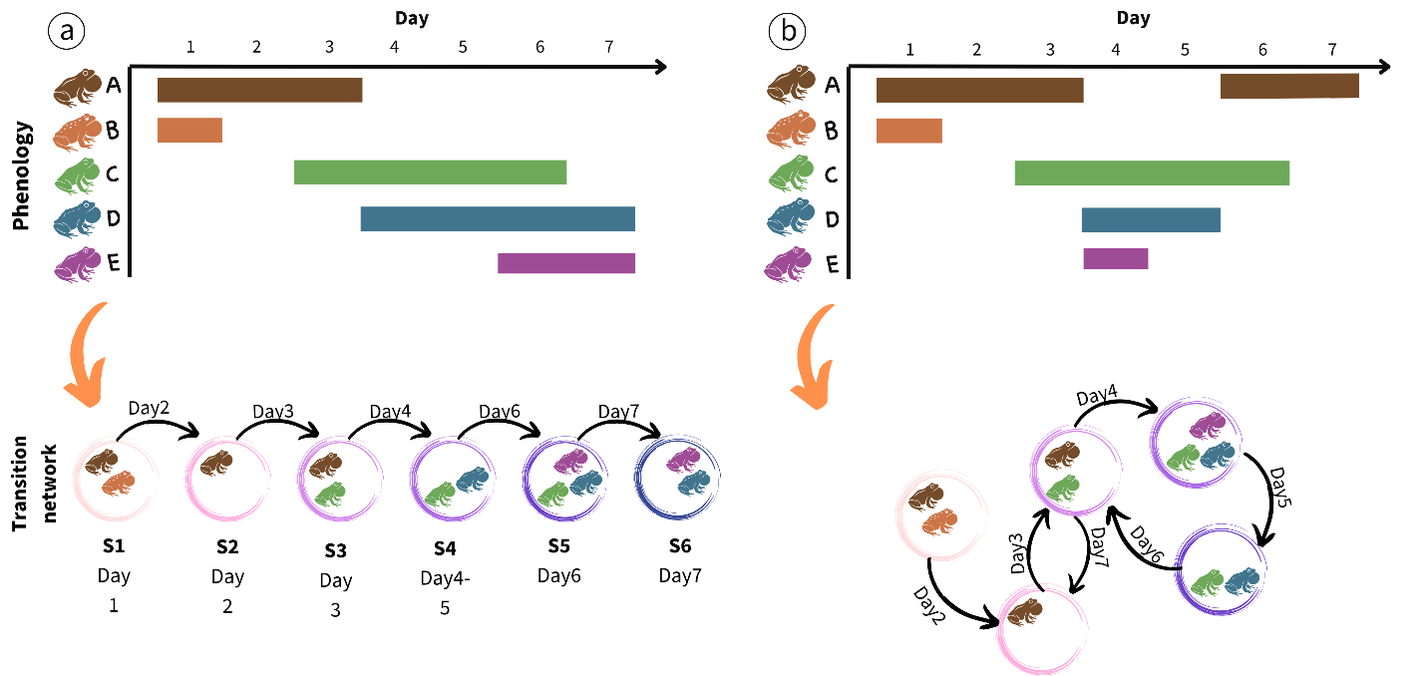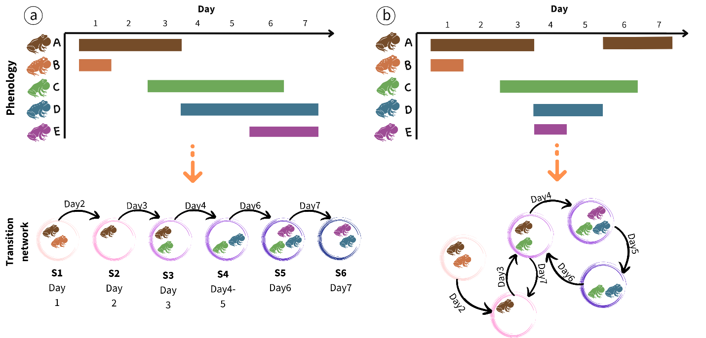

Results
Temporal structure of community transitions
Comparing the community transition networks across 192 different communities revealed a highly dynamic seasonal community structure. Within an annual cycle, communities went through an average of 20.3 (±0.73 SE) unique community states (i.e. combination of co-occuring species) and 88 (±1.99 SE) transitions between states in a single annual cycle, with up to 51 unique community states and 158 transitions (Fig x). This striking diversity of community states and larger number of transitions in a single cycle was possible because each state lasted on average for only 3.1 days (±0.05 SE). Durations followed a negative exponential probability density function, suggesting that the end of state is independent of its duration and instead driven by external factors. This makes sense when considering that transitions between community states depend on the independent activity of each individual species in a community.
The transitions between states were significantly and moderately bursty (mean = 0.21 ±0.01SE, Fig x), revealing that community states formed seasonal clusters, which is consistent with seasonal grouping (guilds) of species. We did not detect a strong signal of temporal memory (mean -0.04, ±0.001, Fig SX), indicating a low predictability for the timing and duration of, and between, events. Together, these results reveal that these anuran communities are volatile and stochastic, with temporally clustered transitions between a diversity of typically ephemeral community states.
Instead of a clear linear seasonal transition between states, transition networks were more complex and interconnected, characterized by repeated transitions between node pairs. The network structure was typically modular (mean= 0.32, ±1.03 SE), revealing that states grouped in more interconnected seasonal clusters. On average, networks had low connectance (0.15 ±0.006SE) relative to the high node diversity, with the short average distance between nodes (mean=2.18 ±0.07SE), and a high betweenness (0.49, ±0.001SE). This indicates that the temporal transition networks of these communities exhibit a “small-world” structure, characterized by high path dependency and transitions between nodes that pass through a small number of central or “hub” nodes. A closer inspection of individual networks revealed that these hubs were typically “empty” states (no active species present) or tended to be single-species states, consisting of species with disproportionately long breeding seasons. 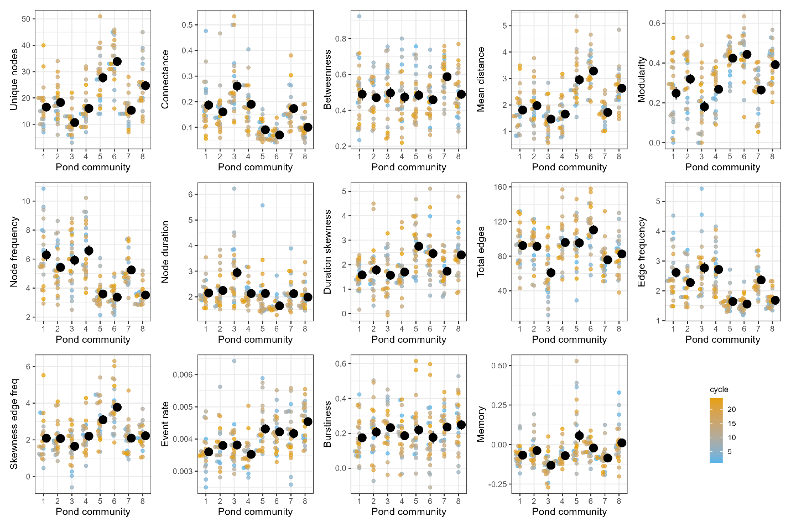
Figure 2: Temporal (seasonal) structure of community transitions varies across sites (ponds) and years. Solid black points indicate pond means ±1SE across annual cycles, and small points indicate the respective metric for a given year, with color indicating the respective annual cycle. See Table X for details on network metrics.
Temporal structure across space and time
Nearly all aspects (Table 1) of the seasonal structure differed significantly across sites and over time. For instance, the number of unique nodes (community states) varied by an order of magnitude (5-51) across all observations, and up to fivefold within ponds across years. This variation in node diversity was largely driven by variation in the number of active species each year, which scaled log-linearly with the number of unique nodes (Fig x). This relationship did not vary significantly across ponds, suggesting that species diversity translates to community state diversity following a general, non-random scaling rule in this system. Furthermore, the realized number of unique nodes vs. the number of theoretically possible nodes increased with the number of species active during a year. This growing disparity reflects the fact that the number of possible species combinations is strongly restricted by their temporal overlap, a fact that is commonly overlooked when studies quantify community structure based solely on the number of species observed at any given time during the year.
However, even after accounting for the number of active species, sites still significantly differed in most of their temporal structure metrics and how they varied across years. Only betweenness, burstiness, and the significant positive correlation between the average duration of community states and their frequency of occurrence each year, appeared largely consistent across ponds (r² mean = 0.561, range= 0.522-0.601, Fig. SX), but still varied substantially over time. Thus, many aspects of the temporal structure of community transitions are shaped by local environmental conditions and composition, but this structure varies significantly over time.
Weather and extreme events alter seasonal transition patterns of communities
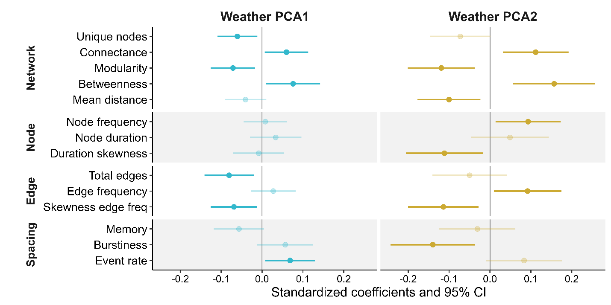
Figure x: Changes in weather conditions help explain inter-annual variation in seasonal community transition networks. X-axis shows effect size of annual weather patterns on individual metrics describing the key aspect of the temporal organization of community states. For easy of comparison, all metrics and climate variables were standardized prior to analysis. See Table x for detailed explanation of metrics and Fig. X for details on PCA loadings.
We found that a significant part of the temporal variation in community structure could be attributed to changes in climatic conditions over the 24-year period. Twelve out of fourteen community transition network metrics were significantly associated with at least one weather principal component axis, including all metrics for network size and structure, as well as the majority of node, edge, and temporal spacing metrics (Fig. X, Table SX).

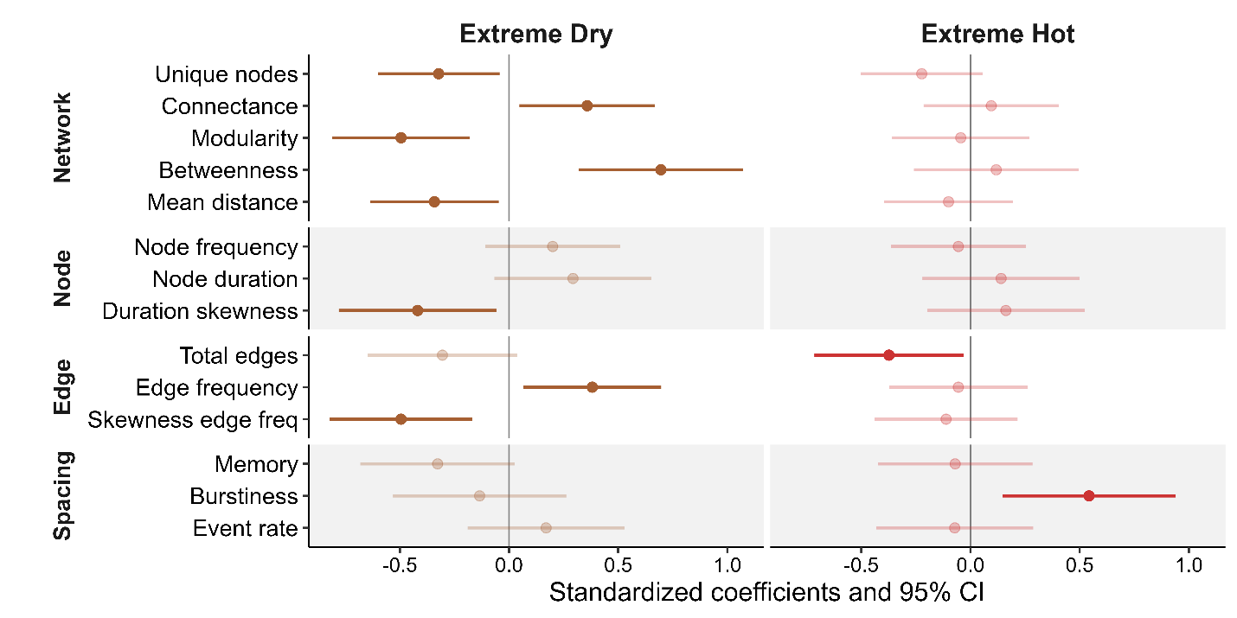
Figure X: Temporal structure of community transition networks changes in years with extreme climatic events. Changes in network metrics describing the temporal changes in seasonal community structure in years with extreme dry (low cumulative rainfall and long dry periods) or hot conditions (high daily maximum temperatures and total number of hot days). See Table X for a detailed description of network metrics and Fig S for extreme years.

While the correlations and complex interplay of the various weather variables make it challenging to isolate the role of any individual climate variable, we can reveal some key drivers by focusing on extreme climatic events. Specifically, we found that the changes in the temporal structure of communities are amplified during more extreme climate events, with drought conditions (characterized by few rain days and low total precipitation) playing a bigger role than a hot climate (characterized by many unusually hot days) (Fig. x). Unusually hot years did not significantly alter most network metrics, but they caused significantly fewer and more bursty (temporally clustered) total transitions between states. However, extreme dry years reduced the number of unique community states (i.e. combination of species) and thus network size. Importantly, this pattern was not driven by changes in the number of active species in given year to year, which did not differ in dry years. Indeed, including the number of observed species as a covariate in the analyses only strengthened the difference between normal and extreme years. Instead, this was at least partially driven by differences in community states. Years with average climate conditions experienced a much more diverse range of species combinations throughout the year and exhibited more sequential transitions between these community states, gradually increasing (or decreasing) the diversity of co-occurring species over time (Fig. x). In contrast, extreme years had much fewer community states with multiple (e.g. three or more) co-occurring species and states were typically connected through single-species and no-species states (Fig x). This decrease in network size in dry years was correlated with an increase in connectance and betweenness, while modularity and mean distance between nodes decreased. Together with the increase in average number of transitions between states, this indicates that dry conditions create smaller, more connected, and more centralized community transition networks, where a few, species-poor community states serve as central hubs that connect unique community states.
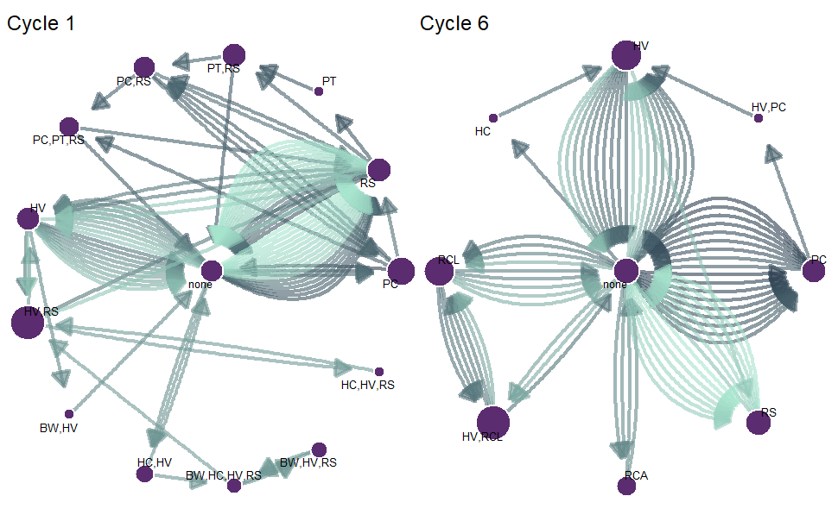

Example: pond 4, both cycle 1 and cycle 6 have total of 5 species (none state), but totally different structure
Discussion
Most analyses on community structure

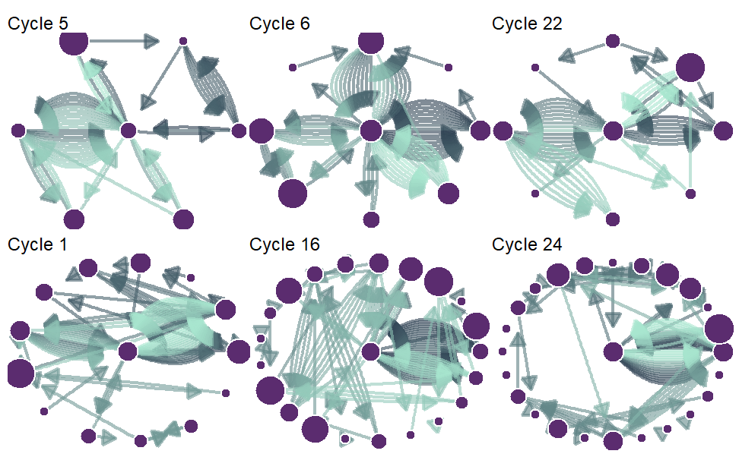

Methods
Quantifying temporal community structure with transition networks
We used time-ordered transition networks to capture the temporal structure of communities within a year (Yin & Rudolf 2024). This approach treats each unique combination of species as a node, and links between nodes indicate a change in community structure when species enter or leave a community. Each node and link has one or more associated timestamps, which indicate the time intervals during which a specific community state or link was active. The structure of such a time-ordered transition network thus depends on the exact sequence and timing of changes in community structure over time. For instance, if states only occur once, we obtain a simple linear network structure, whereas repeating nodes would result in a more complex interconnected network structure (Fig). Importantly, any difference in how a given community changes over time is mirrored in a concurrent change in the structure of these time-ordered transition networks, which we can capture by comparing network metrics (Yin & Rudolf 2024).
Study system & phenology data collection
Amphibians are an excellent system to study the link between the temporal structure of communities and climate. The timing and duration of breeding activity vary across species (Oseen & Wassersug 2002; Carter & Rudolf 2019; Thompson et al. 2022; Benard & Greenwald 2023), resulting in intra-annual changes in calling communities. Because their breeding activity is closely tied to temperature and rainfall, their phenology is significantly influenced by year-to-year variations in weather conditions (Saenz et al. 2006). Furthermore, because species use different climate cues, they also vary in their phenological responses (Cohen et al. 2018), which can reshuffle the temporal structure of amphibian communities across years (Carter et al. 2018; Benard & Greenwald 2023). Finally, Amphibians exhibit some of the strongest phenological responses to climate change (Parmesan 2007), and they are the most threatened vertebrates globally (Luedtke et al. 2023). Identifying how amphibian communities are affected by climate change and extreme events should therefore be a high priority.
We collected high-resolution data on the calling activities (reflecting their respective breeding phenologies) of 12 amphibian species at eight different sites (ponds) in South-East Texas for 24 years (2001-2024). Details of pond characteristics and data collection methods are provided in Carter et al. (2019). Briefly, ponds are clustered in two geographic areas: the Davy Crockett National Forrest and the Stephen F. Austin Experimental Station, with an average distance of 7 km and a maximum distance of 34 km between ponds. We recorded calls each night for six consecutive 1-minute periods during peak calling time (hourly from 21:00 to 3:00) using an automated audio recorder at each site. We processed recordings manually with sonogram references to identify 12 species (Acris crepitans, Gastrophryne caroliensis, Hyla versicolor, Hyla cineria, Incilius (Bufo) valliceps, Anaxyrus (Bufo) woodhousii, Lithobates catesbeiana Lithobates clamitans, Lithobates sphenocephala, Lithobates palustris, Pseudacris crucifer, Pseudacris triseriata). These species interact locally, either via acoustic interference or competition for common resources in the adult or larval stage. To quantify annual changes in community structure, we converted the hourly calling data to nightly presence/absence data of each species and divided the data into annual breeding cycles (“frog years”), which we based on the activities of all species across all years and started on December 7th (see supplemental file).
Climate Data
We obtained daily weather data from the closest public local weather station situated between both pond clusters (Lufkin, Angelina Co. Airport, TX, 31.23593, -94.75468), including daily precipitation (mm), and daily maximum (Tmax) and minimum (Tmin) temperature. In addition, we obtained daily integrated drought severity metrics from the National Integrated Drought Information System (drought.gov), which considers a range of variables to indicate the amount of “missing” rain in an area. We converted the daily five categorical drought indices into a single metric by weighing each category relative to its severity and summing across all categories.
The daily weather was then binned into annual reproductive cycles (“frog years”) to calculate summary statistics for each cycle, including average highest and lowest daily temperature (meanTmax, meanTmin), the sum of extreme hot days (HotDays, i.e. daily Tmax > 35ºC), average daily precipitation (meanPrec), the burstiness of daily rainfall (BurstRain) to capture variation in the number of days between rainfall events, and cumulative number of days without rain (DaysNoRain). These annual weather metrics differed substantially across the 24-year period: The average daily temperature low (meanTmin) and high (meanTmax) per cycle ranged from 8.59 -15.23ºC and 19.30-27.78ºC respectively, with 6-99 days above a maximum temperature of 35ºC per year, and cumulative precipitation from 758.7-1990.1. Finally, we identified years with extreme climatic events based on whether they fell outside the ±1 SD of the mean for a given metric. We created two different sets of extreme years based on temperature versus precipitation: extreme hot years (years with 1 SD above the average mean Tmax or HotDays) and extreme dry years (years with 1 SD below the average meanPrec or above the average number of DaysNoRain).
Table 1: Metrics to quantify different aspects of the temporal structure of communities.
Scope | Metric | Description
Network | No. Species | No. species detected in a year
 | No. Unique Nodes | Metric of network size indicating the total number of unique community states
 | Connectance (weighted) | Metric of network density indicating average transitions (in & out) per community state
 | Modularity | Metric of network structure; higher values indicate more grouping/clustering of community states
 | Betweenness centralization | Metric of network centrality; high values indicate network “bottlenecks” or key node hubs
 | Mean Distance (Average Path length) | Metric of network efficiency; lower values indicate signals can spread faster (small word structure)
Node | Frequency | Average frequency a community state appears
 | Duration | Average duration of states
 | Skewness of duration | Asymmetry in state duration
Edge | Weight | Average frequency of transitions between states
 | Skewness of weight | Asymmetry in frequency across different transitions
Temporal spacing | Burstiness | Temporal distribution of community transitions
 | Memory | Correlation of durations between transition events
 | Event rate | Rate at which transitions accumulate over time

Data analysis
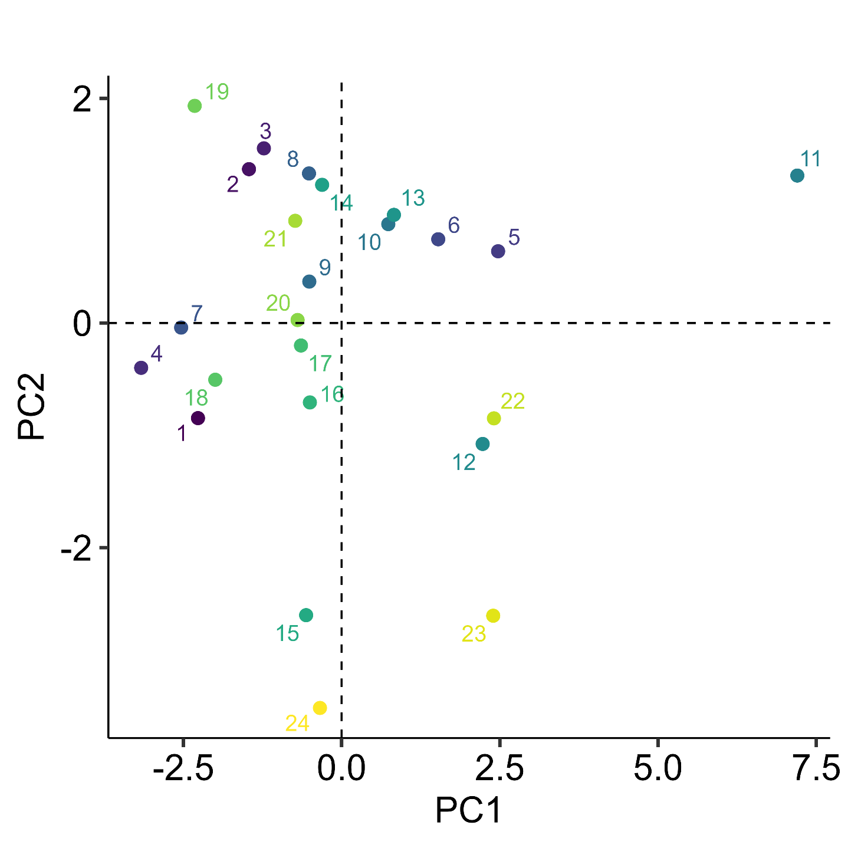
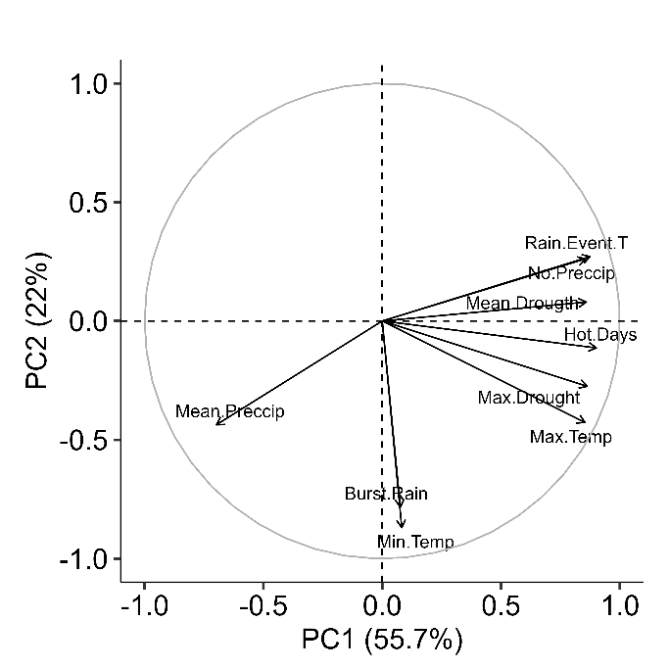
We converted species phenologies to transition networks of communities for each pond and cycle, resulting in total of 192 individual community transition networks (24 years x 8 sites). We focused on different aspects of the temporal structure by calculating a range of key network metrics falling into four broad categories (Table 1). First, we used a time-ordered daily transition network to quantify the durations and frequencies of occurrences of each state, and how these two are correlated. We also calculated the burstiness, memory, and rate of state transitions to determine the temporal spacing patterns of events and the time interval between events. Burstiness determines whether transitions occur randomly, evenly spaced, or aggregated in time. Memory indicates how intervals between events are correlated. Event rate quantifies the average speed at which transitions cumulate over time. To further quantify the transitions patterns between community states, we converted the daily transition networks into an annual Markov transition network, where each link between nodes is directed and weighted by the frequency of its occurrence. For each network, we calculated several key metrics to quantify network structure (the number of unique nodes, connectance, modularity, mean distance, and betweenness weighted by edge frequency), nodes (average number of node occurrence, average and skewness of node duration), and edges (total number of edges; average and skewness of edge frequency). Together, these four groups of metrics (Table 1) provide a detailed picture of how the temporal structure of communities changes over a cycle at a given site and year.
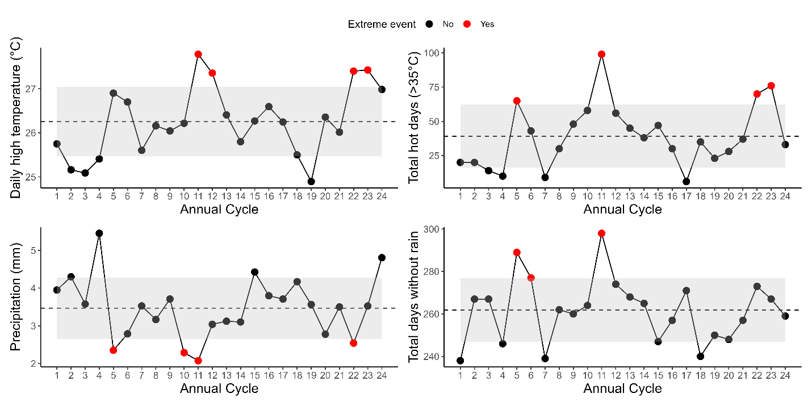
When analyzing how variation in climate affected the community transition patterns, we first standardized all climate and network metrics using a z-score transformation (each variable has a mean of 0 and a standard deviation of 1). We then used a PCA analysis on these standardized metrics to mitigate issues of variance inflation caused by the inherent collinearity among climate metrics. The PCA analysis showed that 78% of the variation in the metrics could be captured by just the first two principal components (PC1= 54.3% & PC2 =23.8%) and any subsequent principal component added <7.6% (Supplement Fig on Axis, see Supplement Fig x for axis loading). We used general linear mixed models and the respective standardized network metrics as response variables, the first two weather principal components as predictors, and pond (site) as a random effect to account for non-independence of repeated observations across years. We also tested how network metrics differ across extreme climate years, using GLMs with extreme heat and drought years each as bimodal predictors, and pond as a random effect. All models fit best with normally distributed errors, except Connectance and mean Distance, which were both log-transformed to improve model fit and error distribution assumptions.
We tested how sensitive the results are to small gaps in calling activity by repeating the analysis in four ways: the original raw data, which treated all days without calling as absence, and three separate analyses that assumed species were still present when gaps (breaks) between calls were only either one (g1), two (g2), or three days (g3). So, if a species is called on days 1 and 3 but not on day 2, it would be considered absent in the raw data, whereas it would be considered present for all three days in the other scenarios. Overall, we found that ignoring small gaps did not qualitatively change any of the patterns and only weakened or strengthened some effects, indicating that our results are robust. Consequently, we present only the results based on raw calling data in the main text (see the supplement for additional analyses).
References
1.
Benard, M.F. & Greenwald, K.R. (2023). Environmental Drivers of Amphibian Breeding Phenology across Multiple Sites. Diversity, 15, 253.
2.
CaraDonna, P.J., Burkle, L.A., Schwarz, B., Resasco, J., Knight, T.M., Benadi, G. et al. (2021). Seeing through the static: the temporal dimension of plant–animal mutualistic interactions. Ecology Letters, 24, 149–161.
3.
CaraDonna, P.J., Iler, A.M. & Inouye, D.W. (2014). Shifts in flowering phenology reshape a subalpine plant community. Proceedings of the National Academy of Sciences of the United States of America, 111, 4916–4921.
4.
Carter, S.K. & Rudolf, V.H.W. (2019). Shifts in phenological mean and synchrony interact to shape competitive outcomes. Ecology, 100, e02826.
5.
Carter, S.K., Saenz, D. & Rudolf, V.H. (2018). Shifts in phenological distributions reshape interaction potential in natural communities. Ecology Letters, 21, 1143–1151.
6.
Cohen, J.M., Lajeunesse, M.J. & Rohr, J.R. (2018). A global synthesis of animal phenological responses to climate change. Nature Climate Change, 8, 224–228.
7.
Inouye, D.W. (2022). Climate change and phenology. WIREs Climate Change, 13, e764.
8.
IPCC (2023). Climate Change 2023: Synthesis Report. Contribution of Working Groups I, II and III to the Sixth Assessment Report of the Intergovernmental Panel on Climate Change In: IPCC (eds. Lee, H & Romero, J) Geneva, Switzerland.
9.
Kharouba, H.M., Ehrlén, J., Gelman, A., Bolmgren, K., Allen, J.M., Travers, S.E. et al. (2018). Global shifts in the phenological synchrony of species interactions over recent decades. Proceedings of the National Academy of Sciences, 115, 5211–5216.
10.
Luedtke, J.A., Chanson, J., Neam, K., Hobin, L., Maciel, A.O., Catenazzi, A. et al. (2023). Ongoing declines for the world’s amphibians in the face of emerging threats. Nature, 622, 308–314.
11.
Olesen, J.M., Bascompte, J., Elberling, H. & Jordano, P. (2008). Temporal dynamics in a pollination network. Ecology, 89, 1573–1582.
12.
Oseen, K.L. & Wassersug, R.J. (2002). Environmental factors influencing calling in sympatric anurans. Oecologia, 133, 616–625.
13.
Ovaskainen, O., Skorokhodova, S., Yakovleva, M., Sukhov, A., Kutenkov, A., Kutenkova, N. et al. (2013). Community-level phenological response to climate change. Proceedings of the National Academy of Sciences, 110, 13434–13439.
14.
Parmesan, C. (2007). Influences of species, latitudes and methodologies on estimates of phenological response to global warming. Global Change Biology, 13, 1860–1872.
15.
Prather, R.M., Dalton, R.M., barr, b., Blumstein, D.T., Boggs, C.L., Brody, A.K. et al. (2023). Current and lagged climate affects phenology across diverse taxonomic groups. Proceedings of the Royal Society B-Biological Sciences, 290, 20222181.
16.
Saenz, D., Fitzgerald, L.A., Baum, K.A. & Conner, R.N. (2006). Abiotic correlates of anuran calling phenology: The importance of rain, temperature, and season. Herpetological Monographs, 64–82.
17.
Schwarz, B., Vázquez, D.P., CaraDonna, P.J., Knight, T.M., Benadi, G., Dormann, C.F. et al. (2020). Temporal scale-dependence of plant–pollinator networks. Oikos, 129, 1289–1302.
18.
Suzuki, S.S., Baba, Y.G. & Toju, H. (2023). Dynamics of species-rich predator–prey networks and seasonal alternations of core species. Nature Ecology & Evolution, 7, 1432–1443.
19.
Thompson, M.M., Rowley, J.J., Poore, A.G. & Callaghan, C.T. (2022). Citizen science reveals meteorological determinants of frog calling at a continental scale. Diversity and Distributions, 28, 2375–2387.
20.
Tonkin, J.D., Bogan, M.T., Bonada, N., Rios-Touma, B. & Lytle, D.A. (2017). Seasonality and predictability shape temporal species diversity. Ecology, 98, 1201–1216.
21.
Winemiller, K.O. (1990). Spatial and temporal variation in tropical fish trophic networks. Ecological Monographs, 60, 331–367.
22.
Wolkovich, E.M., Cook, B.I., McLauchlan, K.K. & Davies, T.J. (2014). Temporal ecology in the Anthropocene. Ecology Letters, 17, 1365–1379.
23.
Yang, L.H. (2020). Toward a more temporally explicit framework for community ecology. Ecological Research, 35, 445–462.
24.
Yin, H. & Rudolf, V.H.W. (2024). Time is of the essence: A general framework for uncovering temporal structures of communities. Ecology Letters, 27, e14481.

Acknowledgments: We thank Cory Adams, James Childress and Alexandria Bryant for contributing in the field and lab. Additional thanks to Amy Dunham and Hanna Yin for comments on the manuscript.
Funding: VHWR was supported by NSF DEB-2445952.
Contributions: Conceptualization, formal data analysis, writing - original draft: VHWR
Data Collection and curation: DS
Writing-editing: VHWR & DS
Competing interests: Authors declare that they have no competing interests.
Data, code, and materials availability: All data, code, and materials are freely available at:

Supplementary Materials
Materials and Methods
Supplementary Text
Figs. S1 to S#
Tables S1 to S#
References (##–##)
Supplemental Figures
Figure S1: The duration and frequency of a state are positively correlated. Small points indicate the correlation coefficient (r²) between the frequency and duration of a community state averaged across a given year and pond, with the size of the point indicating the number of community states observed during a given year and color indicating the annual cycle. Large black points indicate mean ±1SE across years for a given pond commmunity.
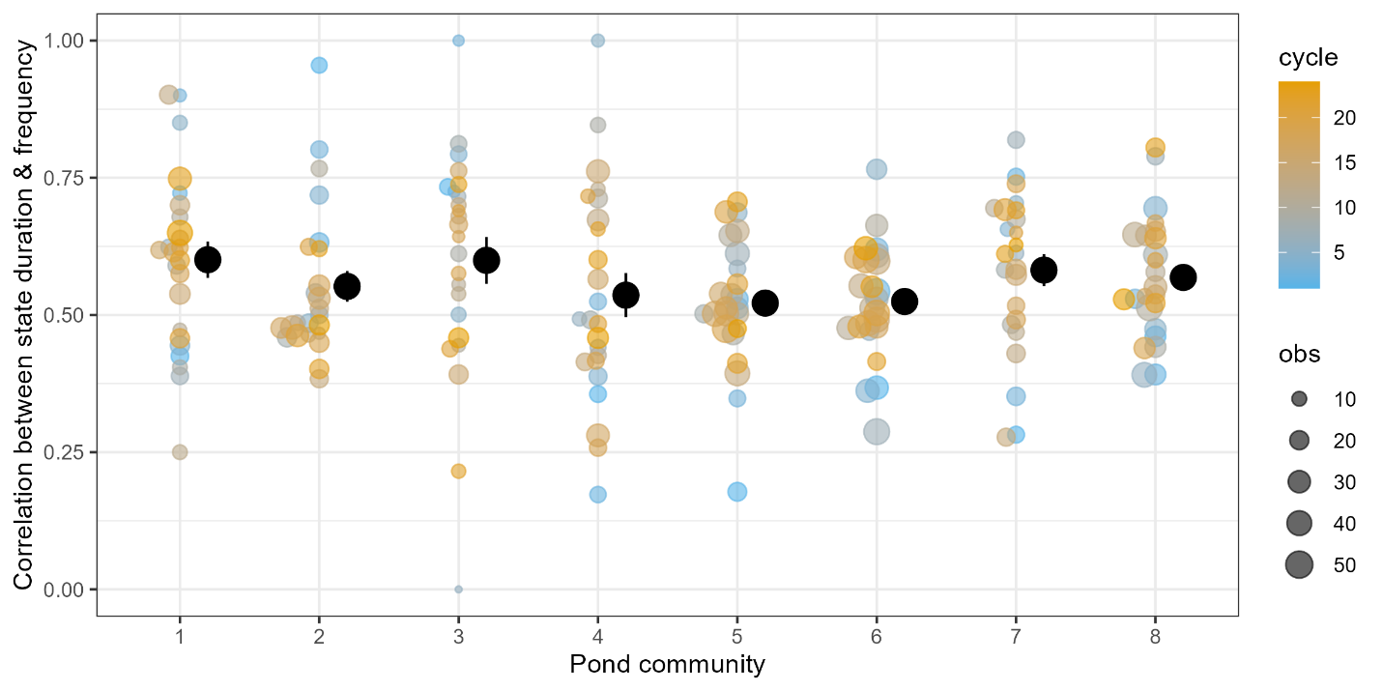

Figure SX The number of unique community states in a transition network scales positively with the number of active species in a given year and pond. The red line indicates the hypothetical maximum number of all possible unique states for a given number of species (without accounting for phenology differences). Points indicate observed data at a given pond and year. The blue line indicates a second-order polynomial model that represented the best fit to the data with grey area indicating standard error interval.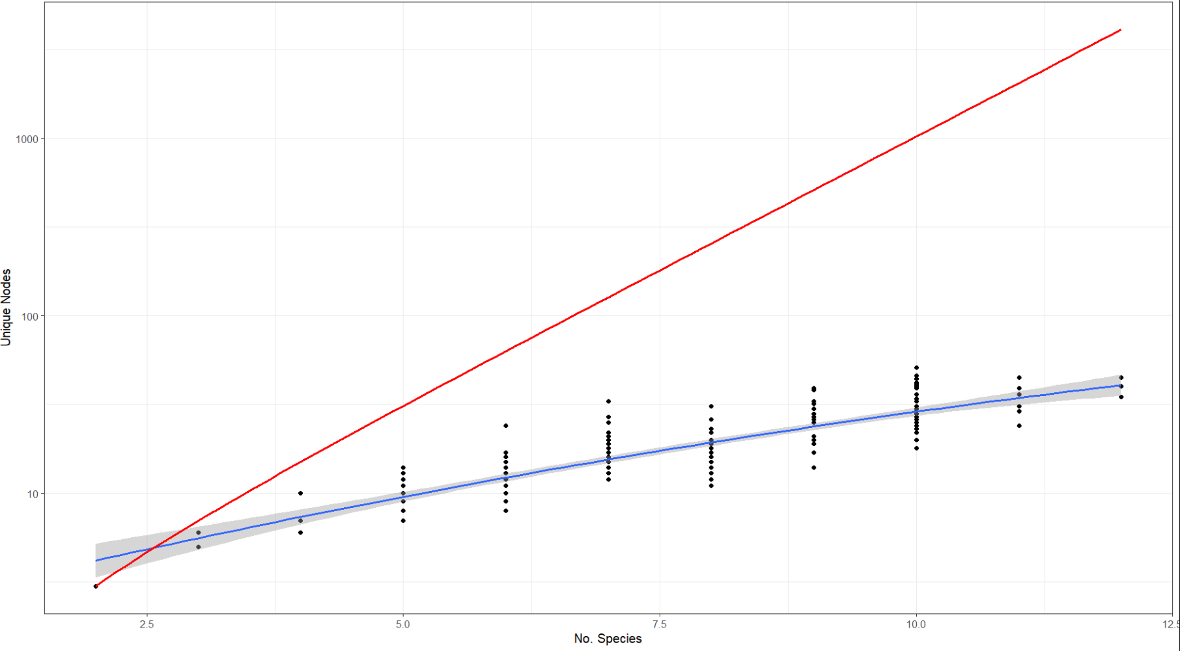

Table S1: Effect of pond identity and cycle on network metrics. Test statistic from a generalized additive model (GAM) fitted to each response variable to test the effect of pond, (annual) cycle, and their potential interactive effect (pond: cycle). The interactive effect was inferred from a lack-of-fit test and indicates whether adding a pond-specific smoothing term significantly improves the fit of the respective GAM. Cycle was fitted as a smoothing term to identify if there is a general temporal trend that is shared across all ponds.
response | pond |  | cycle |  | pond:cycle
 | F | p | F | p | F | p
Unique nodes | 35.61 | 0.0000 | 2.84 | 0.0939 | 2.16 | 0.0000
Connectance | 19.12 | 0.0000 | 2.04 | 0.1552 | 0.28 | 0.0561
Betweenness | 2.24 | 0.0332 | 2.39 | 0.1236 | 0.92 | 0.0013
Modularity | 19.71 | 0.0000 | 2.84 | 0.1108 | 1.09 | 0.0001
Mean distance | 26.14 | 0.0000 | 2.38 | 0.1246 | 0.87 | 0.0085
Node duration | 8.00 | 0.0000 | 3.62 | 0.0586 | 0.69 | 0.0085
Node frequency | 24.03 | 0.0000 | 0.55 | 0.4600 | 1.18 | 0.0000
Duration skewness | 7.53 | 0.0000 | 1.39 | 0.2405 | 0.35 | 0.1138
Total edges | 11.07 | 0.0000 | 3.92 | 0.0493 | 1.28 | 0.0009
Edge frequency | 19.39 | 0.0000 | 2.43 | 0.1350 | 0.61 | 0.0068
Skewness edge freq | 13.73 | 0.0000 | 4.28 | 0.0400 | 0.68 | 0.0146
Burstiness | 1.24 | 0.2844 | 3.26 | 0.0729 | 1.16 | 0.0007
Event rate | 9.09 | 0.0000 | 3.01 | 0.0259 | 0.25 | 0.1368
Memory | 8.76 | 0.0000 | 0.63 | 0.4291 | 0.22 | 0.0966

Table S2: Effect of pond identity and cycle on network metrics after accounting for variation species number. Same as Table S1, but the analysis included the total number of active species observed at a pond each year as a covariate.
